- TRAVEL TIPS AND INTEL

- OFFBEAT

The Odd, Romantic Life of an Engagement Concierge
by Alex Van Buren October 6, 2015

Getty Images/Moment Open
Advertisement

From Sites We Love
- 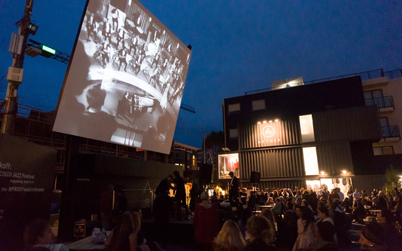
San Francisco Gets New Outdoor Movie Theater and Film
In the Great Debate for U.S. Flights, the Justice Department
- 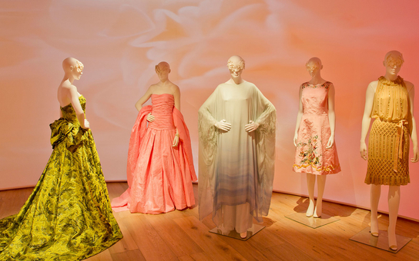
SCAD Opens Major Fashion Museum in Atlanta
powered by PubExchange
Advertisement
What if booking a $239-a-night hotel room with your sweetheart included a free engagement?
As the "engagement concierge" of Santa Fe's La Fonda on the Plaza, Rebecca Hammer has helped plan nearly 50 engagements. During six years of working at the hotel, she’s been the one nervous would-be grooms have called to help set up that magic moment.
We asked Hammer about her favorite engagement, the weirdest request she's received, her success rate (it’s pretty impressive!), and, of course, her tips she has for folks about to pop the question.

Is “Engagement Concierge” really your job title?
I’m actually a “Dynamic Experience Coordinator.” They let me choose my own job title.

What was your career prior to this?
I lived in Santa Fe for 10 years, studying creative writing at the [now-defunct] College of Santa Fe. I used to work at bookstores and in magazines. At school, I studied poetry and essay writing.

Have you always been interested in romance?
Yes. I was a bride for Halloween for a good four or five years, right up to kindergarten. My mom said that getting me dressed up was like getting a bride ready: “I want my makeup like this!”

How’d you get to the point where you were the one arranging these?
Being a concierge, you have to expect everything … but I love engagements and I love love. The second I did my first one I decided that should be my project from here on out. They’re so much fun. You get to be in the background of one of the most special experiences of [people’s] lives.
Birth Control Info
www.Non-Daily-BirthControl.com
Discover a Method of Birth Control
That You Don't Take Daily.

Any tips for would-be grooms after doing 50 of these?
I make sure everything we do is unique to them as a couple. If not, it won’t feel like a natural, happy moment. I find out what she likes, what they like to do together. Being true to who you are is probably my No. 1 thing. It doesn’t have to be big and giant. A really nice dinner goes a long way.

What’s the worst flub you’ve seen?
No flubs! That’s the thing about having me in the background; anything that could go wrong is smoothed over. If you’re running late for the dinner where you’re planning to propose and don’t have time to call, I’m gonna call the restaurant for you.

Any women proposing to men yet? Or same-sex proposals?
Not yet! But Santa Fe is an incredible community … I think that’s coming up. We host quite a lot of gay weddings every year and I’m hoping to see some proposals.

What’s been your favorite proposal?
I organized a flash mob. It was really fun; six or seven of us were all on walkie-talkies. It was such an incredibly sincere proposal—I cried, and every single person working the event cried. All the people holding up the “Will You Marry Me?” sign outside the couple’s window were the bride’s and groom’s friends and family—20 of them. They were living in Albuquerque, an hour’s drive away, and we had to shuttle them through back corridors and pretend they weren’t here.

How about the weirdest?
If it’s what they want, I don’t think it’s a strange request. But we had someone who wanted polar bears—32 stuffed animal polar bears—in the room. In the desert, those are a little hard to come by, but it’s part of their story of how they met. I had to have a staff employee who worked in Albuquerque pick them up on the way into work. The woman walks into the room, sees the room, and I just heard her shriek from down the hall, she was so excited.

We have to ask: Are you married or engaged?
I just got engaged in February! We went out for dinner and I kind of thought it would happen … he went down on one knee right in the middle of the living room.

That’s so straightforward for someone with your job!
I think I’d have been suspicious if it’d been something too crazy… it’s hard-wired in my brain to be suspicious.

Has this job changed your outlook on humanity?
Oh, yeah. I love stories, I love people—it’s what I enjoy most about my job. I’m creating moments in life—that’s really special.

Er, and have any proposals been turned down?
Once.

That’s not a bad record.
It’s not.

That’s life.
It is.

