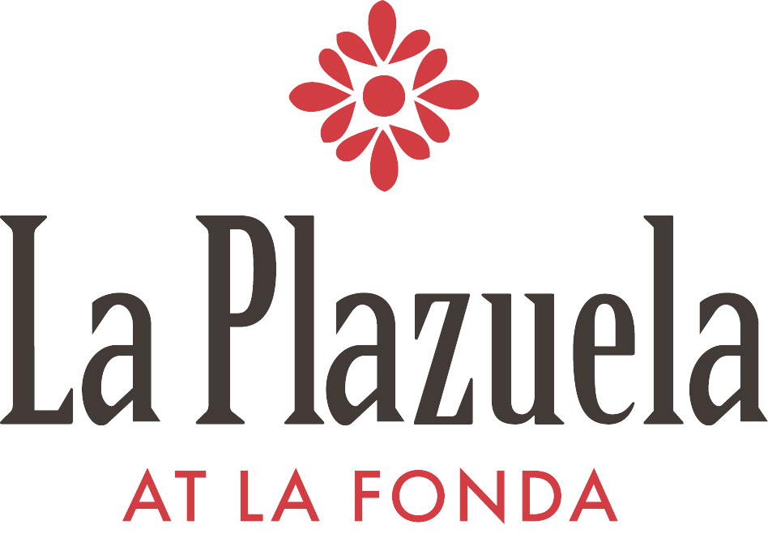

Weekly Dinner Specials

Reservations Recommended

April 9th through April 11th

Char-grilled New Mexico Lamb Chops
Roasted garlic mint sauce
Warm fingerling potato salad
Fresh seasonal vegetables
$36

Apr 16th through Apr 18th
Chile rubbed Jumbo Shrimp Brochettes
Apple-jicama salad,
Roasted piñon,
Mango vinaigrette
$29

Apr 23rd through Apr 25th
Pan Roasted Halibut Medallions
Achiote rub, Lime butter sauce
Grilled vegetable salad,
Rainbow quinoa pilaf
$30

Weekly Dinner Specials

Reservations Recommended

Apr. 30th through May 2nd

Pan Roasted New Mexico Pork Tenderloin
Medallions with pineapple-achiote glaze,
Papaya vinaigrette,
Green herbed rice and,
Fresh seasonal vegetables
$23

May 7th through May 9th

Pan Roasted Turkey Medallions
Pistachio green rice,
BBQ-chipotle vinaigrette,
Mango salsa,
Sautéed spinach
$26

